**IE 260 CLASS EXERCISES - WEEK 9**

1. Acme Semiconductor is expanding its facility and needs to add equipment. There are three process tools under consideration. You have been asked to perform an economic analysis to select the most appropriate tool to acquire. You have gathered the following information for evaluation. Each of these tools has a useful life of seven years. Acme’s accounting staff has established a company-wide MARR of 8% per year.

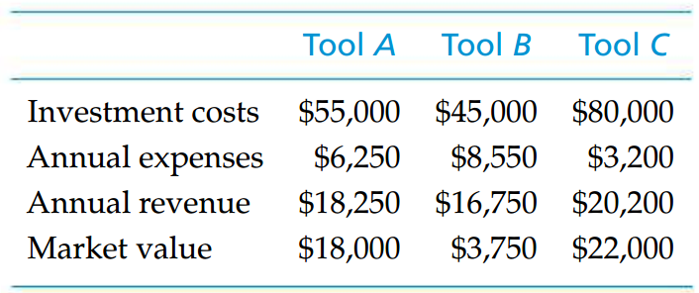

1. Determine the IRR of Each Project.
2. Which one of the process tools should be selected?
3. Why might one project have the highest PW while a different project has the largest IRR?